- Commercial Arithmetic 2
1. The table below shows the rate at which income tax is charged for all taxable income.
INCOME RATE IN EXCH TWENTY SHILLINGS
On the first shs.116 160 10%
On the next shs.109 440 15%
On the next shs.109 440 20%
On the next shs.109 440 25%
On all income over shs.444 480 30%
Mr. Nyongesa earns a basic salary of sh.54, 450 per month. He is housed by the company and therefore 15% of his monthly salary is added to the basic salary as a taxable income. He is also given taxable medical and transport allowances of shs.4,000 and shs.2,000 per month respectively. He is entitled to a family relief of sh.1, 100 per month.
(a) Calculate Nyongesa’s annual taxable income (3 mks)
(b) Calculate his monthly P.A.Y.E after the relief (5 mks)
(c) If 20% of his basic salary goes towards deductions, determine his monthly income. (2 mks)

2. All employees of silver springs enterprises pay income tax at the rate shown in the table below.

Taxable income (p.a) | Rate sh. Per K₤
1 – 3780  3781-7560  7561-11,340  11,341-OVER | 2  3  4  5

Mr. Mooka earns a basic salary of sh.12,150 and a house allowance of sh.2800 per month. He is
entitled to a family relief of sh.450 per month. A part from income tax the following deductions are also made from his monthly pay.
- Servicing loan payment sh.450
- Hospital fund sh.260
- Sacco contribution sh.120

Determine Mr. Mooka’s net monthly income. (10 marks)

3. The taxation rates for income earned in a certain year were as follows:
Income Tax Rate
K£ p.a Kshs. Per £
1 – 4512 2
4513 – 9024 3
9025 – 13536 4
13537 – 18048 5
18049 – 22560 6
Over 22560 6.5
After a personal relief of Kshs.1056 per month, Otieno paid tax amounting to Kshs.18,152 that year.
a) How much tax would he have paid if he did not have the personal relief (2 mks)
b) Find his taxable income in K£ that year (5 mks)
c) If Otieno receives allowances amounting to 18% of the taxable income. Calculate his monthly basic salary in Kshs. (3 mks)
4. Chepkemoi bought a new washing machine for Kshs.420,000. Its value depreciated over
the next 5years at the following rates; 15%, 13%, 12%, 9% and 7%. For the next 6 years,
the rate of depreciation remained constant at 5% then the rate of depreciation remained at 4%
each. How long did it take for the value of the washing machine to be ¹/₃ of its original value?
5. The table below shows income tax rates for the year 2006

Taxable income in shs. Pa | Rate of tax in %
1 – 120,000 | 10
120,001 – 240,000 | 15
240,001 – 360,000 | 25
360,001 – 480,000 | 35
Over 480,000 | 50

Nafula is married and claims a tax relief of shs.1,120 per month. She stays in a company house
For which she pays a nominal rent of shs.1200 per month. She found that in a particular month,
her employer deducted shs.4830 as tax. If she is entitled to a maximum insurance policy; relief
of shs.600 per month. Calculate her monthly salary. (10mks)

6. The figure below represents two pulley wheels, centres A and B with a rubber band
CDEFGHC stretched round them. Radius of wheel centre A = 16cm, AB = 30cm. CD,
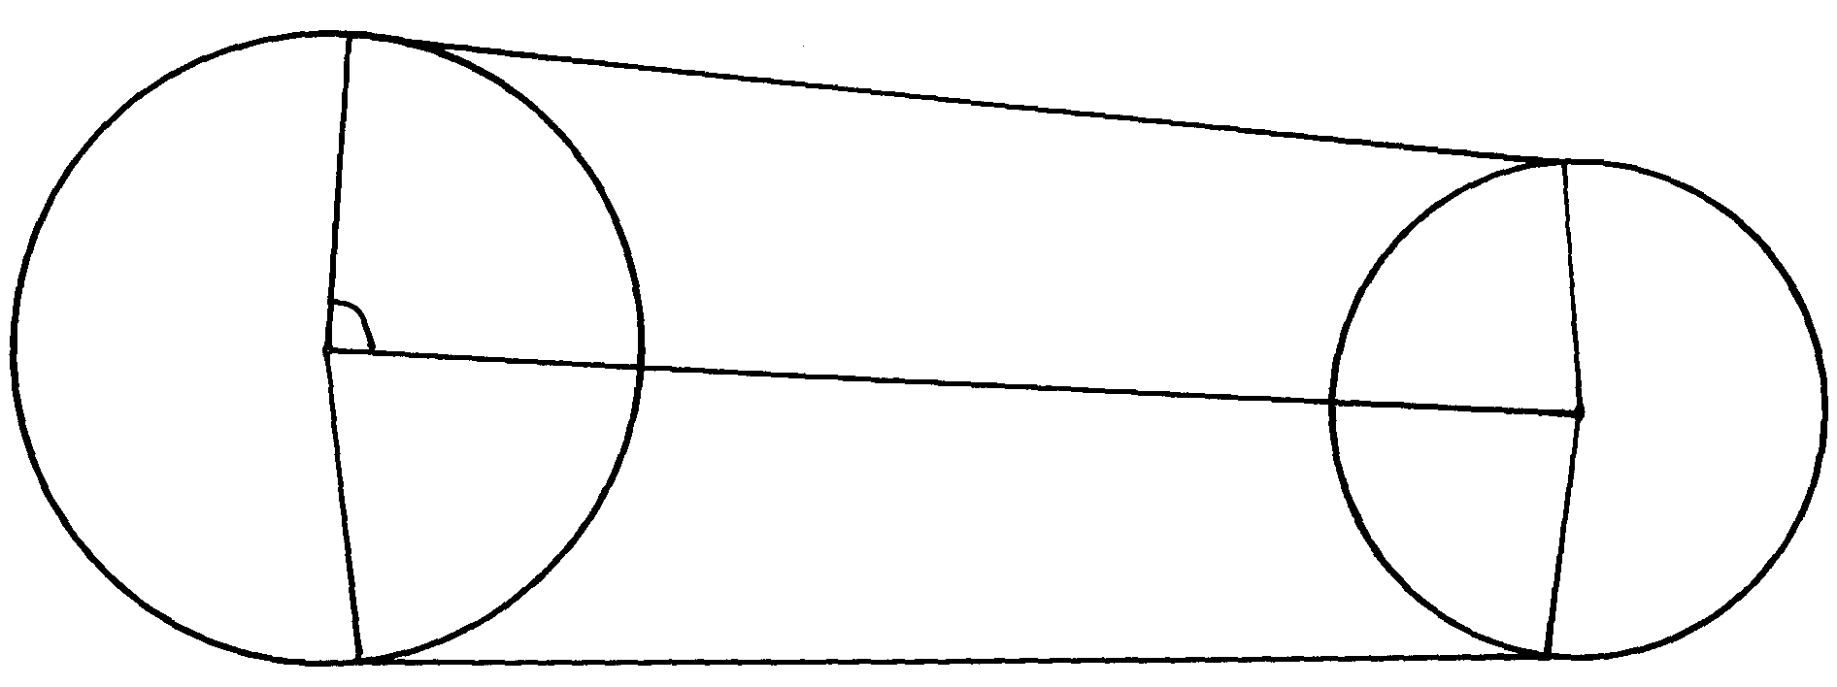
GF are tangents to the circles < CAB = 86.3°
B
F
D
86.3º
G
H
A
C

a) calculate the length of the belt CD
b) Find the angle ABD
c) Find the length of the belt that would go round the pulleys (CDFGHC)

7. In the figure below, ABCD is a cyclic quadrilateral and BD is a diagonal. EADF is a straight line,
∠CDF = 68º, ∠ BDC = 45º and ∠ BAE = 98º.
E
A
D
F
B
C
98º
45º
68º

Calculate the size of:
a) ∠ ABD.
b) ∠ CBD

8. A customer deposited Ksh.15,500 in a savings account. Find the accumulated amount
after 3½ years if interest was paid at 16% per annum compounded semi-annually

9. A retailer mixes three types of rice, Bismatti costing shs.120 per tin with Pishori costing shs.150
per tin and Ahero rice costing shs.80 per tin in the ratio x : 1 : 2 respectively. If he sells the
mixture at shs.137.50 per tin making a profit of 25%. Calculate the value of x.

10. Ashanti is a saleswoman and earns a commission on sales based on the monthly rates shown
in the table below:-
Sales (Kshs) | Commission rate % of sales
The first 5000 | 10%
The next 3000 | 15%
Sales above 8000 | 20%

In addition, she earns a basic monthly pay of Kshs.6700. During a certain month, she earned
a total salary amounting to Kshs.8368. How much worth of sales did she make?

11. The table below shows the annual income tax rates for a certain year.

Total income per month in Kshs. | Rates in Kshs. Per £
1-10164  10165 – 19740  19741 – 29316  29317 – 33892  388983 and above | 2  3  4  5  6
Automatic personal relief shs.1162

Kiptoo earns a monthly salary of Kshs.25000. He is entitled to house and medical allowances
of Kshs.12000 and Kshs.3000 respectively
Calculate:
(a) His taxable income per month
(b) His monthly tax payable
(c)His annual tax payable

12. A company employee earns a basic salary of Kshs.25,000 and is also given taxable allowances
amounting to Kshs.10,480.

Monthly taxable income | Rate in Kshs. /Pound
1- 4350  4351 – 8900  8901 - 13455  13451 – 18005  18006 and above | 2  3  4  5  6

Using the table of taxation above:-
(a) Calculate the employee’s taxable income
(b) If the employee is entitled to a personal tax relief of Kshs.800 per month, determine the net tax
(c) If the employee was given 40% increase in his income, calculate the percentage increase
in his income tax

13. A certain amount of money was invested at compound interest of 10% compounded
every two years for ten years. Given that the investor invested a total of 500,000/= at the
end of the ten years, find the amount of money invested to the nearest shillings

14. The cash price of a T.V set is Ksh. 26,000. Linda bought the set on hire purchase terms by
paying a deposit of Ksh. 6,000 and the balance by 24 equal monthly installments of
Khs. 1,045.30. Find the compound rate of interest per year.
.
15. What would Kshs.15000 amount to after 3years at 16% per annum compounded quarterly?
16 . Income rates for income earned were charged as follows:
Income in Kshs. p.m Rate in Kshs. per sh.20
1- 8400 2
8401- 18,000 3
18,001- 30,000 4
30,000 - 36,000 5
36,001 - 48,000 6
48,001 and above 7
A civil servant earns a monthly salary of Ksh.19,200. His house allowance is Ksh12,000 per
month. Other allowces per month are transport Ksh.1300 and medical allowance Ksh.2300.
He is entitled to a family relief of Kshs. 1240 per month.
Determine:
a) (i) His taxable income per month.
(ii) Net tax. b) In addition, the following deductions were made
NHIF shs. 230
Service charge Kshs. 100
Loan repayment Kshs. 4000
Co-operative shares of Kshs. 1200.
Calculate his net salary per month.

17. Use the taxation rates in the table below to answer the questions that follow;-
Taxable income in K £ p.a | Rate % per K£
1-4500  4501-7500  7501 – 10500  10501 – 13500  13501 – 16500  0ver 16500 | 10  15  20  25  30  35
The manager of a certain company is entitled to a monthly personal relief of shs.3000
and her tax (PAYE) is kshs.9000 per month she is also deducted NHIF shs.350 per month,
WCPS shs.800 per month and cooperative shares shs.1200 per month, calculate
(a) The managers total deductions per month
(b) Total tax per month
(c) The manager’s annual gross salary
(d) The manager’s monthly basic salary if her monthly allowance and medical allowances
are 10000 and 2000 shillings

18. The table below shows the income tax for a certain year;
Monthly taxable income (Kshs.) | Tax rates (%)
1- 9680  9681- 18800  18801 – 27920  27921 – 37040  37940 and above | 10%  15%  20%  25%  30%
In that year, Odero paid a net tax of Kshs.5,512 per month. His total monthly taxable allowances
amounted to Kshs.15,220 and he was entitled to a monthly personal relief of kshs.1,162.
Every month the following deductions were made;
N.H.I.F Kshs.320
Union dues Kshs.200
Co-operative shares Kshs.7,500
(a) Calculate Odero’s monthly basic salary in Kshs
(b) Calculate his monthly salary

19. (a) A car is worth shs.800,000 when new. During the first year it depreciates by 20%
of its value and in the second it deprecates by 5% of its value at the start of the year.
During the third, fourth and fifth year, depreciation rate is 10%. How much less will
it cost at the end of the fifth year?
(b) Find by how much the compound interest will exceed simple interest on shs.3,000
for two years at 15% per year

20. The table below shows the income tax rates:
Income per month (K£) Rate in Kshs per £
1 - 325 2
326 – 975 3
976 - 1300 5
1301 – 1625 6
Over 1625 7.50
Mr. Misoi is a public servant who lives in a government house and pays a nominal rent of Kshs.1,220 per month. He earns a basic salary of Kshs. 24,800 and a house allowance of Kshs.12,000 per month. He is entitled to a monthly relief of kshs.1620.
(a) Calculate his monthly;
(i) Taxable income in K£
(ii) Tax payable without relief
(iii) Tax after relief
(b) Apart from the income tax. The following monthly deductions are made from his earnings
-HELB loan repayment Kshs.2400
- Health insurance fund Kshs.1200
- 2% of Basic salary union fee

Calculate:- (i) the total monthly deduction made on Mr. Misoi’s income
(ii) Mr. Misoi’s net income per month

21. Joseph bought a camera on hire purchase (H.P) term by paying a deposit of shs.7200
and cleared the balance in 24 equal monthly installments each of 1250.
(a) find the hire purchase price of the camera
(b) the hire purchase price of the camera is 24% higher than the cash price. Find the
cash price of the camera
(c) Kangara took a loan from a financial institution and bought the camera with cash.
He repaid the loan at 18% p.a compound interest at the end of the two years. Find
the total interest paid by Kangara.

22. Income tax for all the income earned was charged at the rates shown.
Total Income p.a (K.£) | Rate in sh per K£
1 – 1980  1981 – 3960  3961 – 6440  6441 – 7920  7921 – 9900  Excess of 9900 | 2  3  5  7  9  10
(a) Wanyonyi earned a salary of Kshs.10,500 per month. In addition he was given a house
allowance of Kshs. 6500 per month. He got tax relief of Kshs. 300 per month.
Find ; (i) His taxable income p.a (ii) Income tax he pays per month. (b) A part from income tax the following deductions are made per month. NHIF of Kshs.320,
widow and pension scheme of 2% of his gross salary. Calculate his net monthly pay.

